<EMPTY>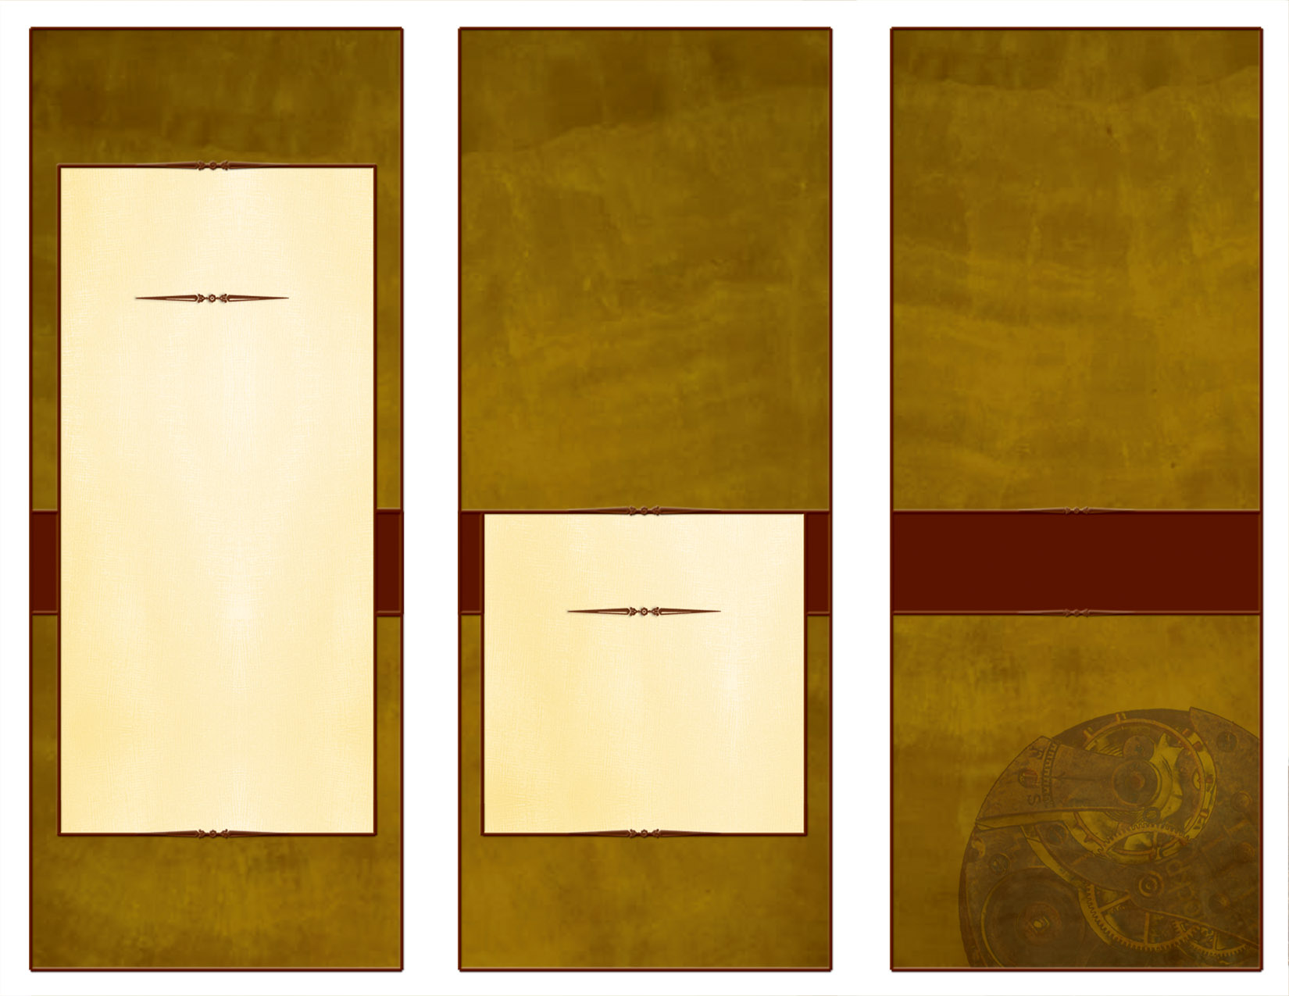<EMPTY>

Our program is based on the latest research suggesting children need to play, and to be outside. It was borne out of a need to bridge Pre-K classes with the new highly academic standards of Kindergarten.

Children who attend our program develop a lifelong love for learning in a beautiful country environment.

Our program is based on the Christopherus model of Waldorf education and Nature Learning as introduced by the Wilderness Awareness School.

*Professionally trained teachers in Education, Music, Art, and Nature.*

Country Knoll School – Waldorf Inspired Nature School Program

Ph 425-844-8607

Conveniently located between the Cities of Carnation and Duvall

countryknollcommunitypreschool.com

email: countryknollschool@gmail.com

*Where children develop a lifelong love of learning in a beautiful natural setting*.

COUNTRY KNOLL – WALDORF INSPIRED NATURE SCHOOL.

Our New Waldorf Inspired Nature School Program

**Delete box,   
or place a   
tag line or quote here.**

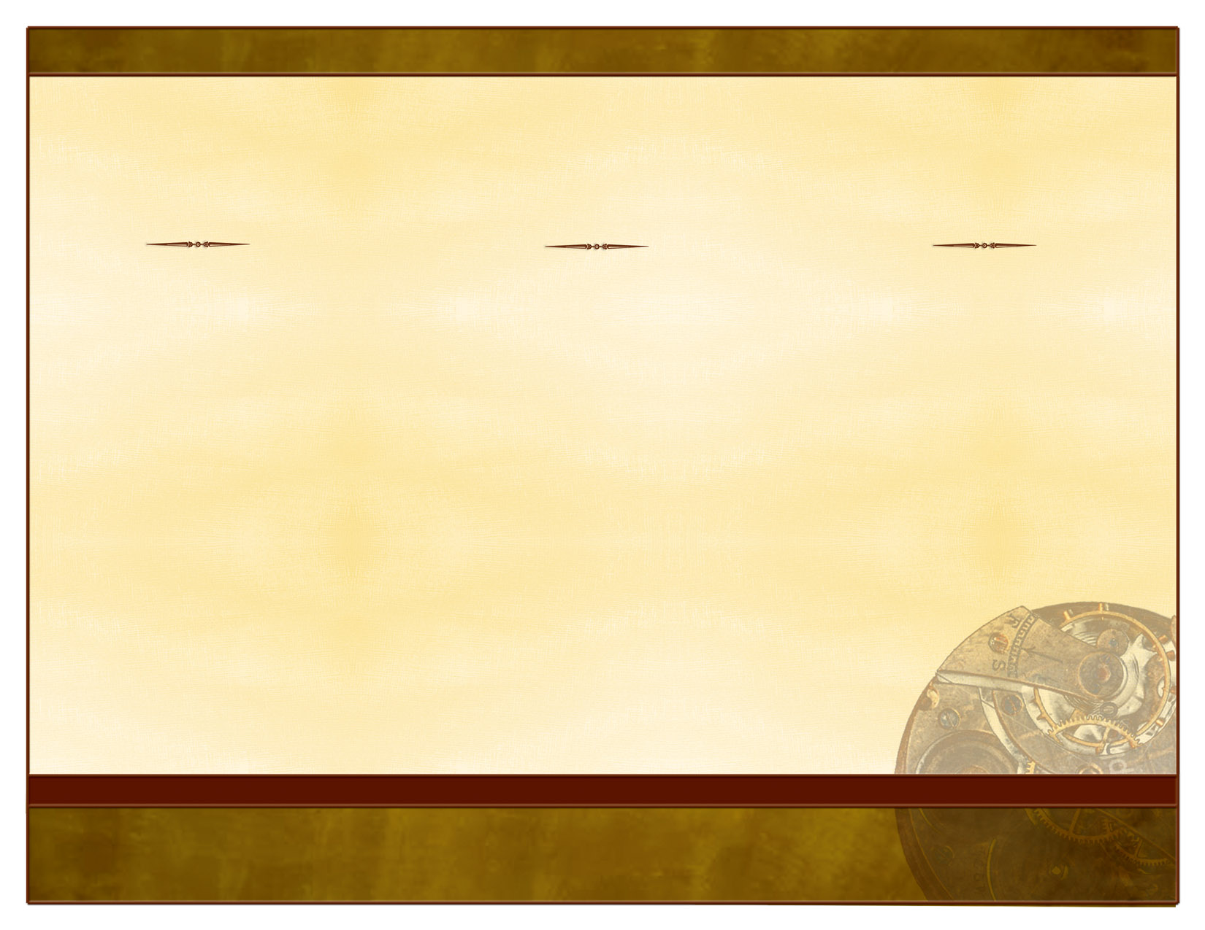<EMPTY>

Receive the children in reverence, education them with love, and send them forth in freedom - R. Steiner

In the woods, we return to reason and faith – RW Emerson

PARENTS: * I am thrilled my daughter is having this experience. * It is so much more than we ever expected.

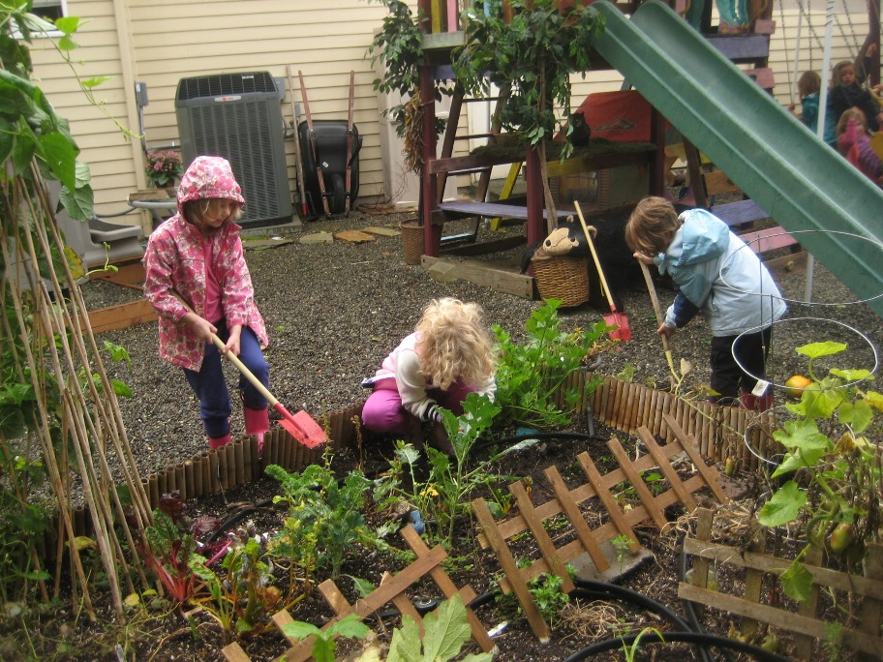

Waldorf teaches core concepts - not simply subjects to be read about, ingested, and tested. They are experienced. Through these experiences, Waldorf children cultivate a lifelong love of learning as well as the intellectual, emotional, physical, and spiritual capacities to be individuals certain of their path and be of service to the world. *Children will learn through*:

* Art, music, fairy tales, dance, performing arts, yoga, nature, gardening, dress-up play, and many more ways
* Using play and rhythm as the central themes for which children will learn
* Writing, numbers, shapes, and other core concepts will be learned through meaningful ways for the child
* Using natural materials to participate in large groups, small groups, and individual projects
* Building minds using imagination
* Understanding the importance of helping others, and reverence for the world

.

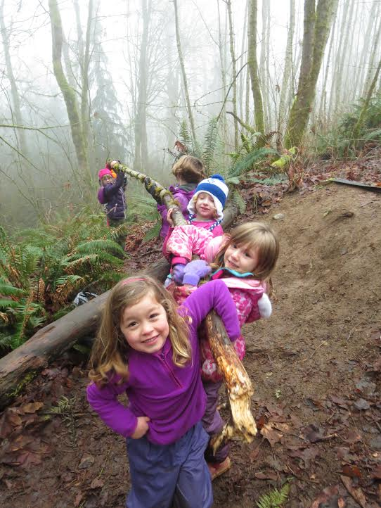

Children will explore the natural world around them through nature activities for kids. They will learn to express empathy for the natural world, comparing species relationships and observing ecological relationships.

Why Waldorf

Why Nature

What is Different from other Educational Programs

SUBHEAD

***Delete box, or add a logo, photo, or other image here. Delete box, or add a logo, photo, or other image here.***

***Delete box, or add a logo, photo, or other image here. Delete box, or add a logo, photo, or other image here.***